**Testing - blog:**

**1. Hint:** Andaman Travel Guide

**Title:** Best places to visit in Andaman and Nicobar Island

**Category:** Island Tour

**Date:** 12/03/2024

**Author:** Sowmiya Ramesh

**Description:** Andaman is a stunning destination full of amazing places to explore. Imagine clear blue seas, golden beaches, and lush greenery everywhere you look, making it the perfect spot for a relaxing getaway. While the island is famous for its beautiful beaches, there are also many hidden gems just waiting to be discovered.

Whether you're an adventurous explorer or simply seeking some peace and relaxation, Andaman has something special for everyone. Here, you can experience both the buzz of city life and the calmness of chilling by the beach. With its beautiful beaches and exciting attractions, Andaman offers plenty of things to do and see.

Join us as we explore some of the best places waiting to be discovered on this enchanting island.

**Quick Links:**

Havelock Island : Experience its Pristine Beauty

Baratang Island: Explore This Hidden Gem

Neil Island: A Beach Paradise with Nature's Charms

North Bay Island: Dive into Summer Fun on this Colorful Island

Ross Island: Discover the Mystery of this Deserted Island

Guitar Island Beach: Enjoy the Serenity of this Unique Destination

Long Island: Experience Stunning Natural Beauty

Viper Island: Explore its Dark History

Ross and Smith Island: A Romantic Escape for Couples

Little Andaman Island: A Mesmerizing Journey to Paradise

**1. Havelock Island : Experience its Pristine Beauty**

Havelock Island stands out as a top destination in Andaman, offering a paradise-like experience for both nature enthusiasts and adventure seekers alike!With its untouched beauty and array of activities, it's no wonder it's such a popular destination in Andaman. From relaxing on the pristine beaches to diving into thrilling water sport activities, there is something for everyone. And the bonus of stunning sunrises and sunsets must make it truly magical.

**Things to do:** Look at the pretty greenery, relax on the beaches, tryout some water activities, and take awesome pictures for your Instagram.

**Places to visit in Havelock Island:** Radhanagar Beach, Vijayanagar Beach, Elephant Beach.

**Activities to do:** Snorkeling and Scuba diving

**2. Baratang Island:** **Explore This Hidden Gem**

Baratang Island is famous for its natural beauty and unique attractions, like quiet beaches, mud volcanoes, and more. When you visit, you'll be amazed by the mangrove forests, lush tropical jungles, and fascinating limestone caves. The island has a mysterious atmosphere that will make you want to discover every corner. You might even encounter some of the local tribes, which adds to the adventure. Enjoy walking around and soaking up the beauty, relaxing on the beaches, and experiencing the magic of this special place.

**Things to do:** Take a stroll and enjoy the beautiful scenery, relax on the beach with a blanket, and have a magical time.

**Places to visit in Baratang Island:** Parrot Island, Baludera Beach, Limestone Caves, Mangrove Forests, and Mud Volcanoes.

**3. Neil Island: A Beach Paradise with Nature's Charms**

Neil Island is a must-see spot in Andaman, renowned for its pristine sandy beaches. The crystal-clear waters and rich wildlife make it stand out. Visitors can engage in various water sports or take a mesmerizing ride in glass-bottom boats to observe the vibrant marine life. Taking a leisurely stroll along the shore, listening to the gentle waves, and leaving footprints in the sand offer a tranquil experience.

**Things to do:** Walk along sandy beaches, admire the clear waters, encounter exotic wildlife, and enjoy thrilling adventures.

**Places to visit in NeiI Island:** Sitapur Beach, Laxmanpur Beach, Bharatpur Beach.

**Activities to do:** Scuba diving, Snorkeling, Glass-bottom boat excursions.

**4. North Bay Island: Dive into Summer Fun on this Colorful Island**

North Bay Island is a popular destination in Andaman that promises an exciting experience. You won't be disappointed here! Explore the diverse marine life, including colorful fish like clownfish and lobsters. The vibrant coral reefs add to the island's beauty. There are plenty of thrilling activities to choose from, making it perfect for adventure lovers. You'll be enchanted by the island's blend of exciting adventures and serene seas.

**Things to do:** Soak up the sun on the beach, relax with scenic views, and try out water sports.

**Place to visit in North Bay Island:** The Lighthouse

**Activities to do:**  Scuba diving, snorkeling, glass-bottom boat rides, semi-submarine tours, jet skiing, sea walking, parasailing, and more.

**5. Ross Island: Discover the Mystery of this Deserted Island**

Ross Island might not be what you expect from a typical island, but that's what makes it unique. It used to be a busy British administrative center, complete with things like a tennis court, printing press, church, and market. Now, it's a hauntingly beautiful place filled with ruins. Even though it's all worn down, exploring these old buildings gives you a peek into the past. The beaches here are great for chilling out and thinking. You'll learn a lot about the British rule and what happened after, which adds an extra layer of interest to your Andaman trip.

**Things to do:** Wander through the remnants of the "Paris of the East," unwind on the beaches, and attend the Light and Sound Show.

**Places to visit in Ross Island:** Animal sanctuary and Japanese Bunker

**6. Guitar Island Beach: Enjoy the Serenity of this Unique Destination**

Guitar Island Beach, named for its guitar-like shape, is a tranquil haven for travelers. Although uninhabited, it boasts stunning tropical beaches, crystal-clear waters, and lush greenery. Escape the hustle and bustle of city life and find peace in the serene surroundings. Whether you prefer lounging on the sand, swimming in the pristine waters, or simply taking a leisurely stroll, this island offers the perfect backdrop for relaxation. Embrace the beauty of simplicity and enjoy a memorable visit to Guitar Island.

**Things to do:** Relaxing on the beach, dipping into the clear waters, and admiring the natural beauty.

**Places to visit in Guitar Island:** Small Guitar Island and Long Island

**7. Long Island: Experience Stunning Natural Beauty**

Long Island welcomes you with breathtaking views of lush greenery, white sandy beaches, and tranquil blue waters. Unlike other tourist spots, this island remains unspoiled, which adds to its charm. Natural wonders like vibrant coral reefs, mangroves, and mysterious caves adorn its landscape. One of the highlights is witnessing the mesmerizing sunsets and sunrises from the beach. You'll be amazed by how well the island has been preserved, offering visitors an unforgettable experience.

**Things to do:** Enjoy water sports, explore beautiful spots around the island, and feel the refreshing sea breeze.

**Places to visit in Long Island:** Lalaji Bay, Yerrata Creek, Merk Bay.

**Activities to do:** Snorkeling, Dolphin watching, scuba diving, fishing, swimming

**8. Viper Island: Explore its Dark History**

Viper Island holds a grim reminder of British rule in India, where Indian freedom fighters were punished and tortured. Visitors can see the remains of these historical sites and learn about this dark period in history. However, the island also offers beautiful beaches and fascinating ancient ruins to explore. It's a journey through the past that combines history with natural beauty, making it a noteworthy destination to visit.

**Things to do:** Learn about India's independence struggle, relax on the beaches, and watch the light and sound show.

**Places to visit on Viper Island**: Samundar Marine Museum and Chatham Saw Mill.

**9. Ross and Smith Island: A Romantic Escape for Couples**

Ross and Smith Island are like a dream come true for couples. These twin islands are connected by a sandy pathway that appears during low tides, giving you the chance to explore both at once. The lush greenery against the backdrop of blue waters creates a stunning setting perfect for romance. The secluded beaches invite you to simply relax and enjoy each other's company. Keep an eye out for Olive Ridley turtles, which call this island home. And don't miss the opportunity to witness breathtaking sunsets, making your visit truly unforgettable.

**Things to do:** Walk between the islands, relax on the beaches, and watch turtles return to the sea.

**Places to visit in Ross and Smith Island:** Marine Sanctuary

**Activities to do:** Scuba diving, Snorkeling, and Hiking

**10. Little Andaman Island: A Mesmerizing Journey to Paradise**

Little Andaman Island is like finding a hidden gem, with its natural beauty captivating every visitor. From its pristine beaches to its charming attractions, this island has it all. While there are many places to explore in Andaman and Nicobar, none compare to the allure of Little Andaman. It offers the perfect blend of excitement and tranquility. Surfing is a major draw for tourists, and the island's sights are equally appealing.

**Things to do:** Discover caves, waterfalls, and white sandy beaches, and enjoy water sports.

**Places to visit in Little Andaman Island:** Elephant lumbering activities, Kalapathar Beach, Butler Bay Beach.

**Activities to do:** Elephant safari, surfing, glass-bottom boat rides, scuba diving, snorkeling.

**FAQ**

1. How to reach Andaman?

Andaman can be reached by direct flights or ferry services, offering both air and sea travel options.

2. Which is the best time to visit Andaman?

November to April is the best time to visit Andaman, offering pleasant weather conditions for exploring the islands.

3. What are the top tourist attractions in Andaman?

Top tourist attractions in Andaman include Cellular Jail, Radhanagar Beach, and Ross Island, each offering unique experiences.

4. What are the activities to do in Andaman?

Snorkeling, scuba diving, trekking, and marine life exploration are popular activities in Andaman.

5 . How many days are enough for an Andaman trip?

A week is usually sufficient to explore the main attractions in Andaman.

6. What are the best beaches in Andaman?

Radhanagar Beach, Elephant Beach, and Vijaynagar Beach are must-visit beaches in Andaman.

**Url:** best-places-to-visit-in-andaman-and-nicobar-island

**Meta Title:** Best places to visit in Andaman and Nicobar Island

**Meta Descriptions:** The Best Places to Visit in Andaman and Nicobar Islands · 1. Port Blair · 2. Havelock Island · 3. Baratang Island · 4. Neil Island · 5. Ross and

**Meta Keywords:** Best places to visit in Andaman and Nicobar Island, Places to visit in Havelock Island, Places to visit in Baratang Island, How to reach Andaman, Which is the best time to visit Andaman, best beaches in Andaman

---------------------------------------------------------------------------------------------------------------------------------------------

**1. Hint:** Explore Kerala

Banner image:

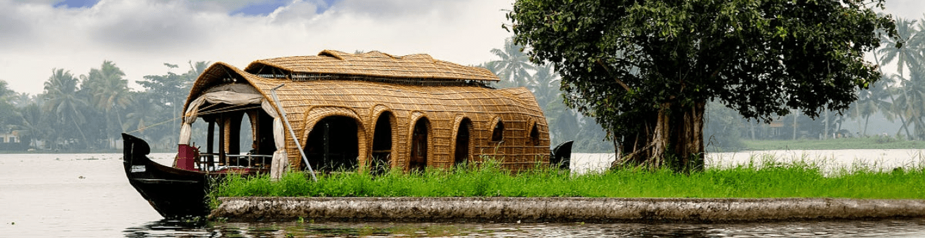

Grid image:

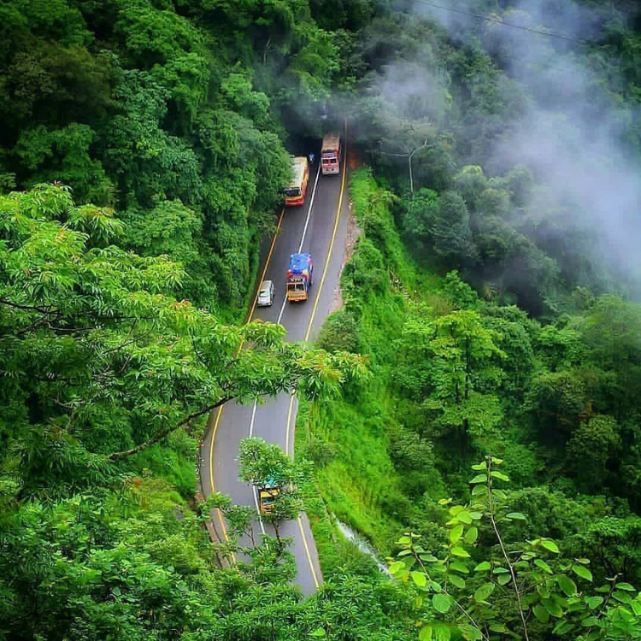

Cover image:

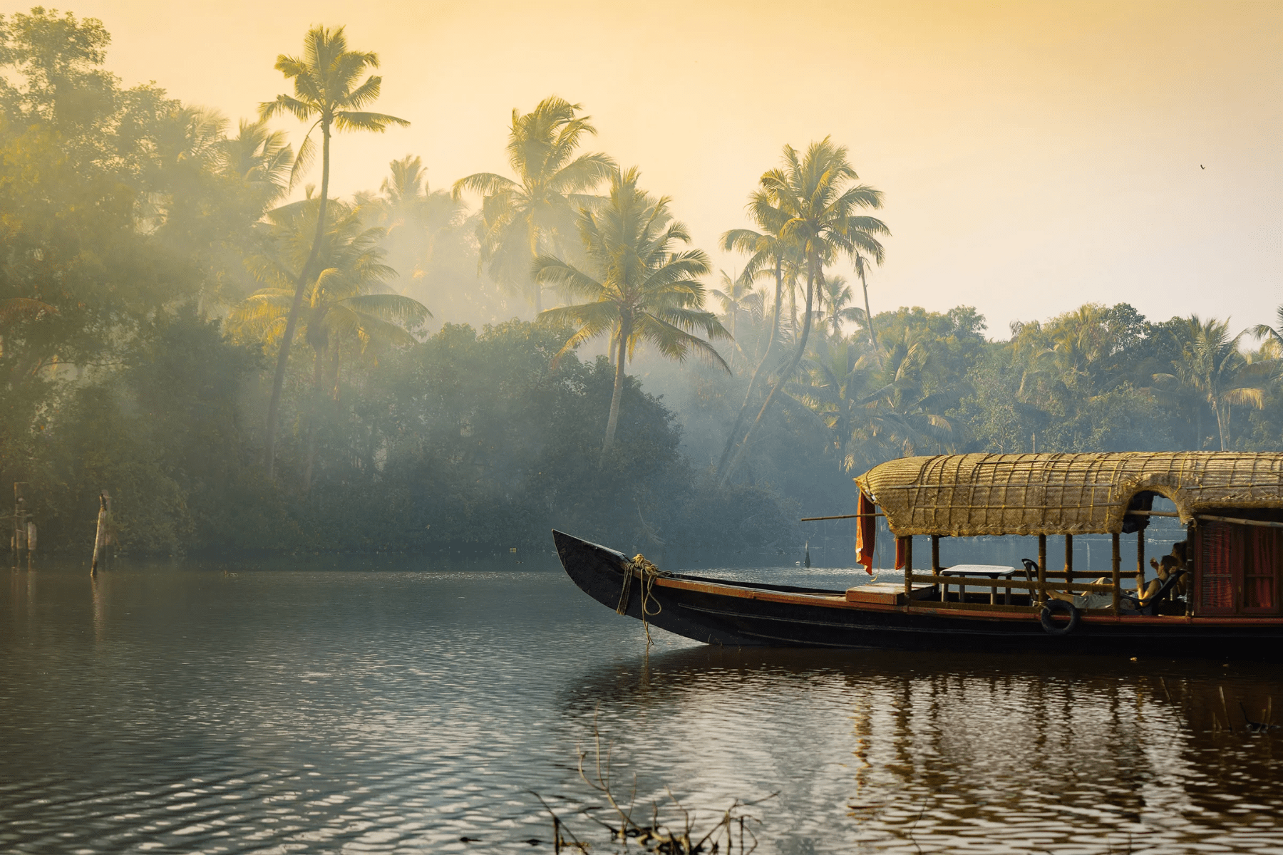

**Title:** **Where Nature Meets Serenity - Your Perfect Getaway Awaits!**

**Category:** Domestic Tour

**Date:** 12/03/2024

**Author:** Sowmiya Ramesh

**Description:** Join us on an unforgettable journey to Kerala, also known as "God's Own Country." With the Arabian Sea on one side and a network of peaceful canals, lakes, and backwaters on the other, this southern gem is famous for its stunning nature, vibrant culture, and rich heritage. Kerala's lush green landscapes, with rolling hills, captivating waterfalls, and dense forests, are truly unique

**Quick Links:**

1. **Places To Visit In Kerala/ Things to do in Kerala**
2. **Best Time to visit In Kerala:**
3. **FAQs:**

Kerala's backwaters are a unique treasure, offering tranquil boat rides in traditional houseboats known as 'Kettuvallams.' These boats allow you to witness the harmonious coexistence of nature and human life along the backwaters

Kerala's culture is as diverse as its landscapes, with classical dance forms such as Kathakali and Mohiniyattam originating here. The state's music, known as Carnatic music, is deeply rooted in classical traditions. Not to mention the delectable Kerala cuisine, which is known for its fresh ingredients, coconut, and an array of spices. Don't miss the traditional Kerala Thali, a must-try for foodies. Come, let's explore this paradise together!

## Places To Visit In Kerala/ Things to do in Kerala

**1. Alappuzha(Alleppey)**

Alappuzha, also known as Alleppey, is famous for its enthralling backwaters, peaceful houseboat rides, and intricate network of canals. This Kerala treasure offers a tranquil escape where visitors can float through lush landscapes, watch traditional snake boat races, and relax on its pristine beach. Alappuzha, with its unique blend of nature and culture, is a must-see destination for those looking for a peaceful and picturesque retreat.

**Places to visit:**

**Things to do: House Boat stay,**

**2. Munnar**

Munnar is famous for its lush tea plantations, cool climate, and breathtaking natural beauty. The region is known for its rich biodiversity and adventure activities such as trekking. It's a peaceful destination in Kerala, India, ideal for nature lovers and those looking for a relaxing getaway.

**Places to visit:**

**Things to do:**

**3. Wayanad**

Wayanad is famous for its picturesque natural landscapes, which range from lush hills to dense forests. It's a wildlife enthusiast's paradise, home to elephants and tigers. Trekkers and campers can trek, camp, and explore ancient caves, while tea and coffee plantations provide a taste of the region's agriculture. Wayanad's cultural diversity and pleasant year-round weather make it a popular tourist destination in southern India.

**Places to visit:**

**Things to do:**

**4. Kovalam**

Kovalam is famous for its beautiful beaches, water sports, and iconic lighthouse. Visitors flock to enjoy Ayurvedic treatments, cultural performances, and delectable local cuisine, with a focus on fresh seafood. The relaxed atmosphere and stunning sunsets make it a top destination for a peaceful coastal getaway.

**Places to visit:**

**Things to do:**

**5. Varkala**

Varkala is famous for its beautiful beaches, particularly Papanasam Beach, which is said to have holy water. Visitors are drawn to the stunning cliff views along the Arabian Sea, spiritual sites such as the Janardanaswamy Temple, and a thriving Ayurvedic wellness scene. It's a cultural melting pot where you can also enjoy water sports and spectacular sunsets.

**Places to visit:**

**Things to do:**

**6. Thiruvananthapuram**

Thiruvananthapuram, Kerala's capital, is known for historic sites such as the Padmanabhaswamy Temple and the Kuthira Malika Palace. It is well-known for its beautiful beaches, including Kovalam, and vibrant cultural traditions such as Kathakali dance. The city is also a center for education, research, and healthcare, and its rich history and natural beauty attract tourists.

**Places to visit:**

**Things to do:**

**7. Vagamon**

Vagamon, known as the "Scotland of Asia," is famous for its lush green hills, meadows, and pine forests, which provide scenic landscapes for nature lovers. In the cool climate, visitors can partake in adventure activities such as paragliding and trekking. It also has tea gardens, religious sites, and a tranquil lake, making it an appealing destination for both adventurers and those looking for a peaceful getaway.

**Places to visit:**

**Things to do:**

### 

**Best Time to visit In Kerala:**

Kerala, located between the Western Ghats and the sea, has a pleasant climate all year, making it a great place to visit at any time. The two main season5s are monsoon and summer. The dry season lasts from December to February, while the hot and humid summer lasts from March to the end of May.

**Summer in Kerala (March - May):**

The summer season runs from March to May. Temperatures can reach 38 degrees Celsius during these months, and the sun's afternoon intensity can reach a scorching 40 degrees Celsius. It's a time when the air becomes humid, especially along the coasts. However, don't be put off by the heat because Kerala's summer also brings vibrant festivals such as Thrissur Pooram, Kanathurkava Uthsavam, and Lokanarkavu. So, despite the rising temperature, there's always something new to discover. As a result, summer is the best time to visit Kerala.

**Monsoon season in Kerala (June-August):**

The monsoon season in India lasts from July to August. The majority of the state receives heavy precipitation, and as a result, the moisture level is at an all-time high. However, the temperature is also very pleasant, as the backwaters are seen spouting to their full potential. During these months, you can witness celebrations such as Ramdan, Pongal, Id-UI-Fitr Kalampattu Festival, and others. It will be a wonderful experience to enjoy the festivals as part of your Kerala tour packages.

**Winter in Kerala (October - February):**

Winters arrive in Kerala slowly, beginning in mid-September and lasting until February. This season brings with it a drop in temperature and humidity, making it an ideal time for exploration. Winter is often regarded as the best time to visit Kerala. It's when you can go on wildlife safaris or go on sightseeing tours around the state. The pleasant weather and low humidity make it an ideal time to explore Kerala's natural and cultural treasures.

### FAQs:

Q: What Are Some Popular Tourist Attractions In Kerala?  
  
A: Kerala Is Known For Its Beautiful Landscapes Backwaters Beaches Wildlife Sanctuaries Hill Stations And Cultural Heritage. Some Popular Tourist Attractions Include The Backwaters Of Alleppey And Kumarakom Munnar Hill Station Periyar Wildlife Sanctuary Wayanad Fort Kochi And The Famous Temples Like Padmanabhaswamy Temple And Sabarimala.  
  
Q: Is Kerala Known For Its Cuisine?  
  
A: Yes Kerala Is Renowned For Its Distinctive Cuisine Which Often Features Coconut Rice Spices And Seafood. Some Popular Dishes Include Appam Puttu Idiyappam Fish Curry Avial And Banana Chips. The Malabar Region Of Kerala Is Especially Famous For Its Unique Flavors And Culinary Traditions.  
  
Q: Where Is Kerala Located?  
  
A: Kerala Is A State In The Southwestern Region Of India. It Is Located On The Malabar Coast Bordered By The States Of Karnataka To The North And Tamil Nadu To The South.  
  
Q: What Is The Capital Of Kerala?  
  
A: The Capital City Of Kerala Is Thiruvananthapuram Often Referred To As Trivandrum. It Is Located On The Southwestern Tip Of The State.  
  
Q: Where Is Kerala Located?  
  
A: Kerala Is A State In The Southwestern Region Of India. It Is Located On The Malabar Coast Bordered By The States Of Karnataka To The North And Tamil Nadu To The South.

**Url:** where-nature-meets-serenity-your-perfect-getaway-awaits!

**Meta Title:** Where Nature Meets Serenity - Your Perfect Getaway Awaits!

**Meta Descriptions:** Kerala's culture is as diverse as its landscapes, with classical dance forms such as Kathakali and Mohiniyattam originating here.

**Meta Keywords:** kerala hidden gems, kerala tour packages guide, best time to visit kerala, munnar tourist places, places to visit in kochi

---------------------------------------------------------------------------------------------------------------------------------------------Hint - Explore Andaman:

Banner image:

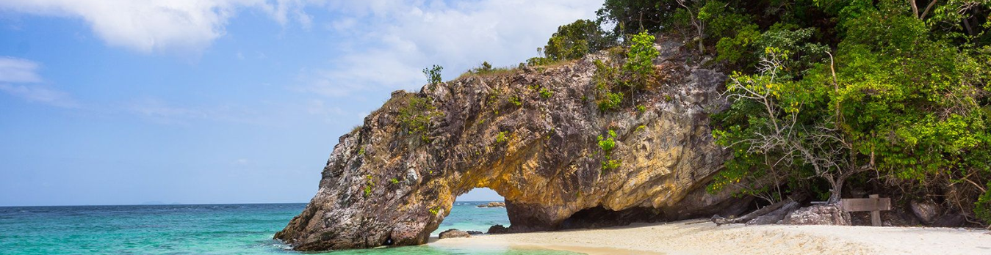

Grid image:

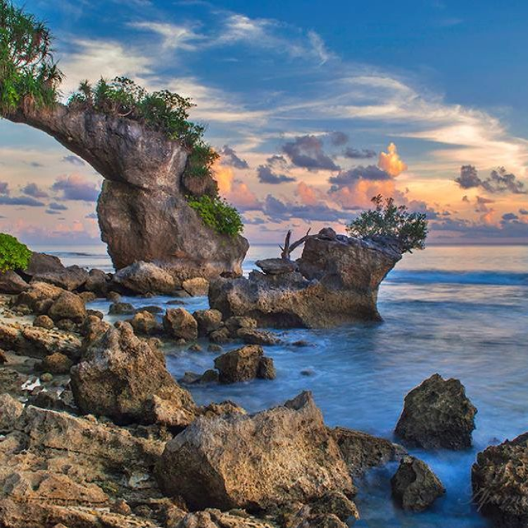

Cover image:

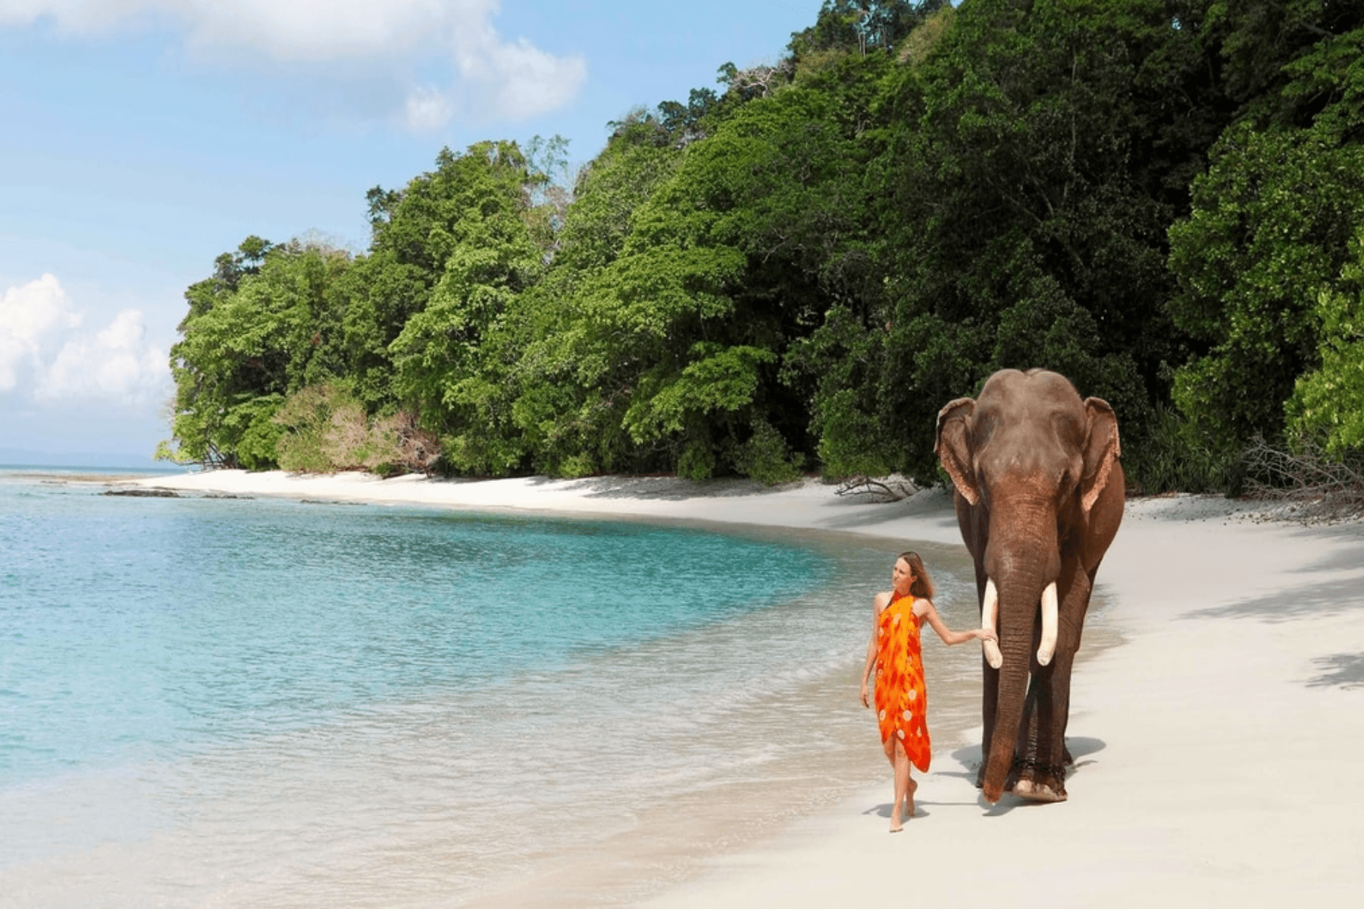

**Title:** **Where Nature Meets Serenity - Your Perfect Getaway Awaits!**

**Category:** Domestic Tour

**Date:** 12/03/2024

**Author:** Sowmiya Ramesh

**Description:** Explore India's hidden paradise in the Bay of Bengal, the Andaman and Nicobar Islands. It's a nature lover's paradise, complete with pristine beaches, lush rainforests, and vibrant marine life.

**Quick Links:**

1. **Places To Visit In Andaman / Things to do in Andaman**
2. **Best Time to visit In Andaman:**
3. **FAQs**

If you're planning a trip to this fascinating archipelago, our blog is your resource for the best places to visit, things to do, the best time to go, and answers to frequently asked questions.

If you're looking for expert guidance and assistance in planning your Andaman and Nicobar vacation, consider reaching out to [Vacation Feast Travel Company](https://www.vacationfeast.com/) for a personalized and memorable experience.

## Places To Visit In Andaman / Things to do in Andaman

**Radhanagar Beach (Havelock Island)**

Radhanagar Beach is famous for its breathtaking beauty, which includes powdery white sand, clear blue waters, and lush greenery. Tourists flock to see the stunning sunsets and enjoy activities like swimming and snorkeling in the calm waters. It's a great place to relax and do water sports in the Andaman and Nicobar Islands because of its cleanliness and peaceful atmosphere.

**Places to visit:**

**Things to do:**

**Cellular Jail (Port Blair)**

The Andaman and Nicobar Islands' Cellular Jail is well-known for its connection to India's struggle for independence. During British colonial rule, it served as a harsh prison for Indian freedom fighters. The architecture of the jail, with seven wings radiating from a central watchtower, is notable. It is now a popular tourist destination and a symbol of India's liberation struggle.

**Places to visit:**

**Things to do:**

**Neil Island**

Neil Island, which is part of the Andaman and Nicobar Islands, is known for its pristine beaches, vibrant coral reefs, and breathtaking sunsets. It provides excellent snorkeling and diving opportunities, as well as clear waters and a relaxed atmosphere, making it an ideal destination for nature enthusiasts and those seeking a tranquil getaway.

**Places to visit:**

**Things to do:**

**Baratang Island**

Baratang Island in the Andaman and Nicobar archipelago is known for its breathtaking limestone caves, unusual mud volcanoes, and the enthralling Parrot Island. Its lush mangrove forests and tranquil beaches provide a haven for nature enthusiasts. Because of its rich biodiversity and adventure activities, the island is a one-of-a-kind and less-crowded destination for those looking for natural wonders in the Andaman and Nicobar Islands.

**Places to visit:**

**Things to do:**

**Mahatma Gandhi Marine National Park**

The Mahatma Gandhi Marine National Park in the Andaman and Nicobar Islands is famous for its stunning coral reefs and abundant marine life. Visitors flock to this park to experience the park's underwater wonders through activities such as snorkeling and scuba diving. It is a popular destination for marine enthusiasts and nature lovers due to its crystal-clear waters, vibrant corals, and diverse fish species.

**Places to visit:**

**Things to do:**

**Best Time to visit In Andaman:**

The winter months, from October to April, are perfect for visiting the Andaman and Nicobar Islands. Because of the pleasant weather and calm seas, this is considered the peak tourist season. Here's a list of the seasons:

**Winter season (October to April):**

This is the best time to go. With temperatures ranging from 20°C to 30°C, the weather is pleasant. The seas are calm, making it ideal for water sports such as snorkeling and scuba diving. It's also the best time for beach trips and island exploration.

**Summer Season (May to September):**

The islands are open for tourism during this period, but it is the off-season due to the southwest monsoon. The weather is hot and humid, with a higher chance of rain and thunderstorms. Water activities may be restricted during this time.

**Monsoon season (June-September):**

This is the wettest time of year in the Andamans. Heavy rain and strong winds are common, causing choppy seas and transportation disruptions. During the monsoon season, tourist activities are limited.

### FAQs

**1.Is a permit required in order to visit the Andaman Islands?**

To visit the Andaman Islands, visitors from India do indeed require a permit. This permit can be picked up at Port Blair when you arrive, or you can apply online ahead of time.

**2. Is swimming in the Andaman Islands safe?**

In popular beaches and designated areas, swimming is generally safe. But always heed local advisories and guidelines, particularly in the monsoon season.

**3. Are there ATMs available on the islands?**

Major towns like Havelock and Port Blair have ATMs. It's best to bring extra cash because there may not be as many ATMs on certain islands.

**4. Is it possible to use a phone on the islands?**

Although mobile phone networks exist, connectivity in isolated places might be restricted. Don't forget to ask your service provider about network coverage and roaming.

**5. In the Andaman Islands, what are the rules regarding plastic and alcohol**

Some islands have restrictions on the sale and use of alcohol, and they forbid the use of plastic bags. Make sure to follow these guidelines and dispose of waste in an environmentally friendly manner to help preserve the environment.

**Url:** where-nature-meets-serenity-your-perfect-getaway-awaits!

**Meta Title:** Where Nature Meets Serenity - Your Perfect Getaway Awaits!

**Meta Descriptions:** Explore India's hidden paradise in the Bay of Bengal, the Andaman and Nicobar Islands. It's a nature lover's paradise, complete with pristine beaches, lush rainforests, and vibrant marine life.

**Meta Keywords:** activities to do in andaman, andaman and nicobar islands nightlife, andaman and nicobar famous festival

---------------------------------------------------------------------------------------------------------------------------------------------

**Hint:** VIETNAM TOURISM

**Banner image:**

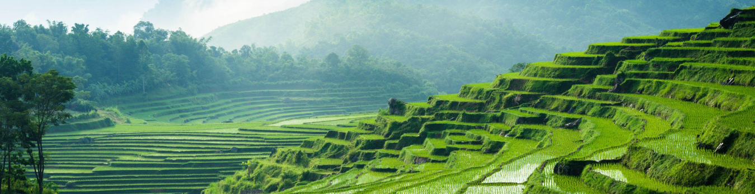

**Grid image:**

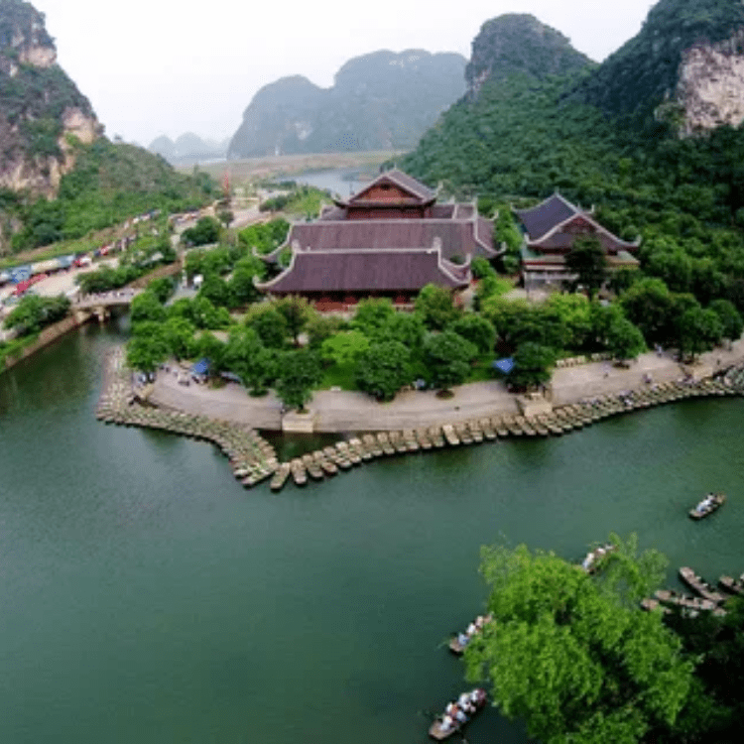

**Cover image:**



**Title:** Vietnam Tourism - Unveiling the Hidden Gems

**Category:** Domestic Tour

**Date:** 12/03/2024

**Author:** Sowmiya Ramesh

**Description:** Nestled in the heart of Southeast Asia, Vietnam is a captivating land where ancient traditions harmoniously blend with modern advancements, creating a captivating tapestry of experiences for travelers seeking an unforgettable adventure.

**Quick Links:**

1. Vietnam places to visit

2. Things to do in Vietnam

3. Best time to travel Vietnam

4. Conclusion

5. FAQ

From its breathtaking natural beauty to its rich cultural heritage and tantalizing cuisine, Vietnam offers an abundance of treasures waiting to be discovered. Join us as we discuss must-see locations, thrilling activities, and answers to frequently asked questions about your [fantastic trip to Vietnam.](https://www.vacationfeast.com/tour-destination/vietnam/)

**Vietnam places to visit:**

**Ha Long Bay:** Immerse yourself in the ethereal beauty of Ha Long Bay, a UNESCO World Heritage Site adorned with towering limestone karsts that rise majestically from the emerald waters. Explore hidden caves and secluded lagoons, and as dusk descends, witness the mesmerizing spectacle of the bay illuminated by a thousand twinkling lights.

**Hoi An:** Step back in time as you wander through the charming streets of Hoi An, an ancient town adorned with well-preserved wooden houses and colorful lanterns. Explore the bustling markets, savor delectable fusion cuisine, and immerse yourself in the town's vibrant art and crafts scene.

**Nha Trang:** Indulge in the idyllic coastal paradise of Nha Trang, where pristine white-sand beaches stretch along the turquoise water of the South China Sea. Bask in the sun's warmth, engage in exhilarating water sports, and savor the freshest seafood delicacies.

**Mekong Delta:** Embark on a captivating voyage through the labyrinthine waterways of the Mekong Delta, a vast expanse of rice paddies, floating markets, and serene villages. Gliding through the canals, witness the vibrant lifestyle of the local communities, sample exotic fruits, and immerse yourself in the region's unique culture.

Saigon's Vibrant City Life:

Dive into the dynamic energy of Ho Chi Minh City (Saigon), where modern skyscrapers stand alongside French colonial architecture, bustling markets, and a lively street food scene.

Perfume Pagoda's Spiritual Journey:

Embark on a spiritual pilgrimage to the Perfume Pagoda, a complex of Buddhist temples set amidst stunning limestone cliffs and lush forests.

**Things to do in Vietnam:**

Cruise in Halong Bay:

Opt for an overnight cruise to fully appreciate the beauty of Halong Bay's emerald waters, limestone karsts, and floating fishing villages. Explore hidden caves, kayak through serene lagoons, and enjoy a breathtaking sunrise or sunset on the deck of your cruise ship.

Explore Hanoi's Old Quarter:

Get lost in the narrow, bustling streets of Hanoi's Old Quarter, known for its historical architecture, vibrant markets, and traditional Vietnamese charm. Discover ancient temples, shop for unique souvenirs, and indulge in local street food.

Visit the Ho Chi Minh Mausoleum:

Pay a visit to the final resting place of Ho Chi Minh, the revered leader of Vietnam's struggle for independence. The mausoleum is an imposing structure surrounded by beautiful gardens and other notable landmarks.

Trek in Sapa:

Embark on a trekking adventure in Sapa to explore the terraced rice fields and interact with the ethnic minority communities.Sapa offers various trekking routes with stunning landscapes, including the famous Fansipan trek.

**Best time to travel Vietnam:**

November to April (Cool and Dry Season):

* This period is considered the best time to visit most parts of Vietnam.
* November to February: Northern Vietnam (Hanoi, Sapa) experiences cool temperatures with a chance of light drizzle. Halong Bay is also pleasant during these months.
* March to April: Spring brings warmer temperatures and blooming flowers. Central Vietnam (Hue, Hoi An) is especially delightful during this time.

May to August (Hot Season):

* This period is characterized by higher temperatures and occasional showers.
* May to June: Warm temperatures in the north, with occasional rain. Central Vietnam experiences increasing temperatures.
* July to August: Hot and humid conditions throughout the country. Central Vietnam may experience occasional typhoons.

September to October (Rainy Season):

* The rainy season brings heavy downpours, particularly in the central and northern regions.
* September to October: Central Vietnam (Hue, Hoi An) experiences heavy rainfall, and there is an increased risk of typhoons. The north (Hanoi, Sapa) also receives rain, but it's generally less intense.

Choosing the best time to visit depends on your preferred weather conditions and the specific regions you plan to explore. Remember that Vietnam is a long and narrow country with diverse landscapes, so weather conditions can vary significantly from one region to another. Always check current weather forecasts and [travel advisories](https://www.vacationfeast.com/) before planning your trip.

**Conclusion:**

In conclusion, Vietnam is a treasure trove of experiences waiting to be uncovered. [Vacation Feast](https://www.vacationfeast.com/) invites you to embark on a journey where every moment tells a story and every destination is a chapter in a captivating travel narrative. Whether you seek cultural immersion, historical exploration, or simply want to unwind in breathtaking landscapes, Vietnam has it all.

**FAQ:**

Q1: Is Vietnam safe to visit?  
Yes, Vietnam is generally safe for travelers. However, it's recommended to exercise standard safety precautions and stay informed about local conditions.

Q2: What currency is used in Vietnam?  
The official currency is the Vietnamese Dong (VND). While major establishments may accept credit cards, it's advisable to carry cash for smaller vendors.

Q3: Do I need a visa for Vietnam?  
Yes, most visitors require a visa. Vacation Feast suggests checking specific requirements based on your nationality and travel plans.

Q4: How is transportation within Vietnam?

Vietnam has an extensive transportation network. Travelers can use trains, buses, domestic flights, and taxis to get around. Motorbike taxis (xe om) and cyclos are also common in cities.

Embark on this extraordinary journey with [Vacation Feast](https://www.vacationfeast.com/) and create memories that will last a lifetime. Explore Vietnam's wonders with us, and let the adventure begin!

**Url:** vietnam-tourism-unveiling-the-idden-gems

**Meta Title:** Vietnam Tourism - Unveiling the Hidden Gems

**Meta Descriptions:** Nestled in the heart of Southeast Asia, Vietnam is a captivating land where ancient traditions harmoniously blend with modern advancements, creating a captivating tapestry of experiences for travelers seeking an unforgettable adventure.

**Meta Keywords:** vietnam tourism, things to do in vietnam, places to visit in vietnam, best time to visit vietnam

---------------------------------------------------------------------------------------------------------------------------------------------